**2023-1 Solid Mechanics Midterm Exam**

(2023.04.25)

『Please write all the answers on this test sheets. You can also use the back side for the answers.』

1. There are two vectors: , and . Draw on the 1-unit graph paper. [5 Points]

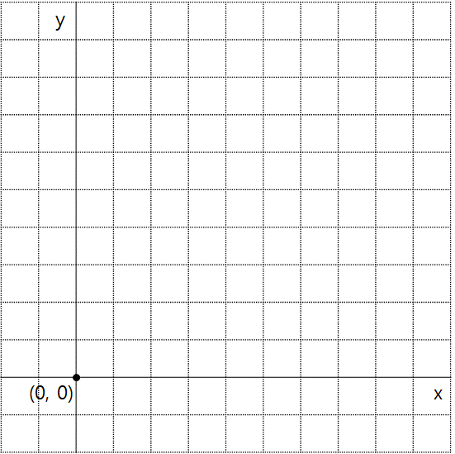

2. Calculate the inner product of (of Problem 1). [5 Points]

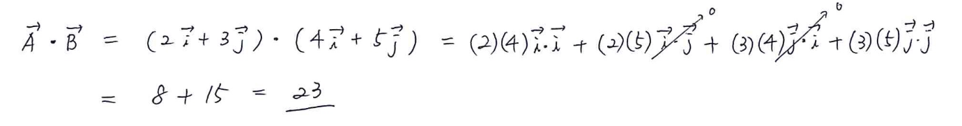

3. Calculate the cross product of (of Problem 1). [5 Points]

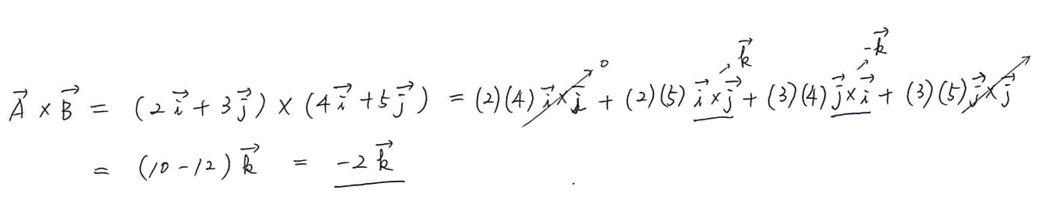

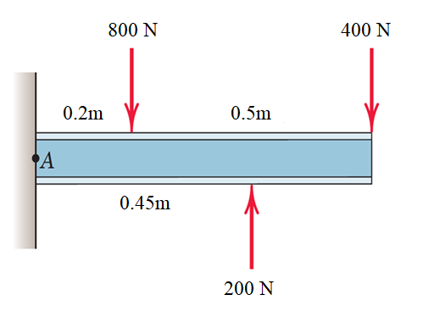4. Express the force-couple system at point A, and calculate the distance x to express the force-couple system as only one resultant force. [Total 12 Points (Answer: 3 Points, Equations: 9 Points)]

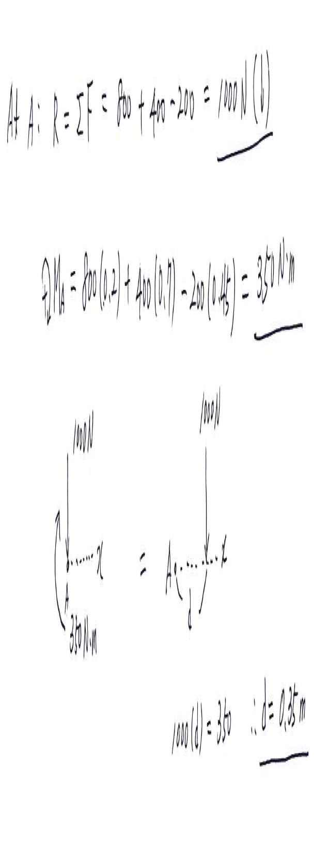

5. Calculate the reaction forces at point O. (Neglect the mass of the beam.) [Total 12 Points (FBD: 4 Points, EoM: 6 Points, Answer: 2 Points)]

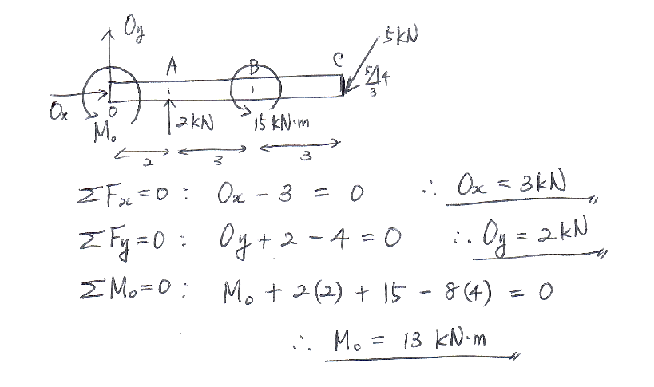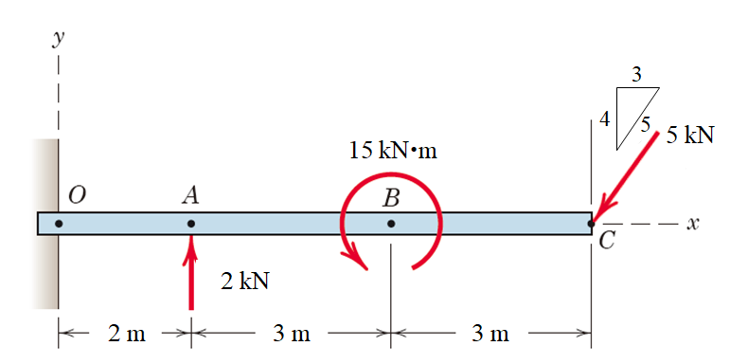

6. Calculate the magnitude of the moment about the base point O of the 600-N force in five different ways. [Total 15 Points (3 Points each)]

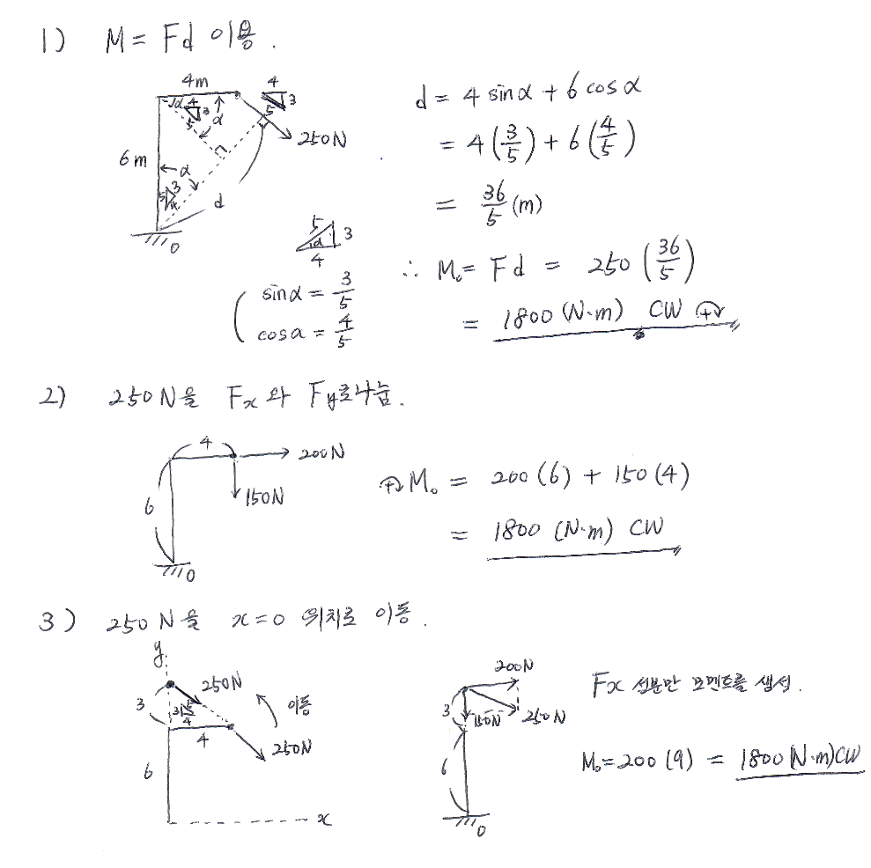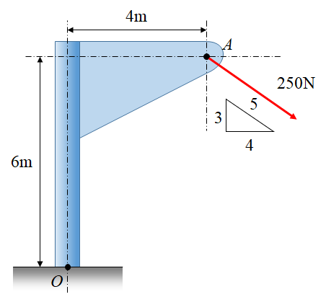

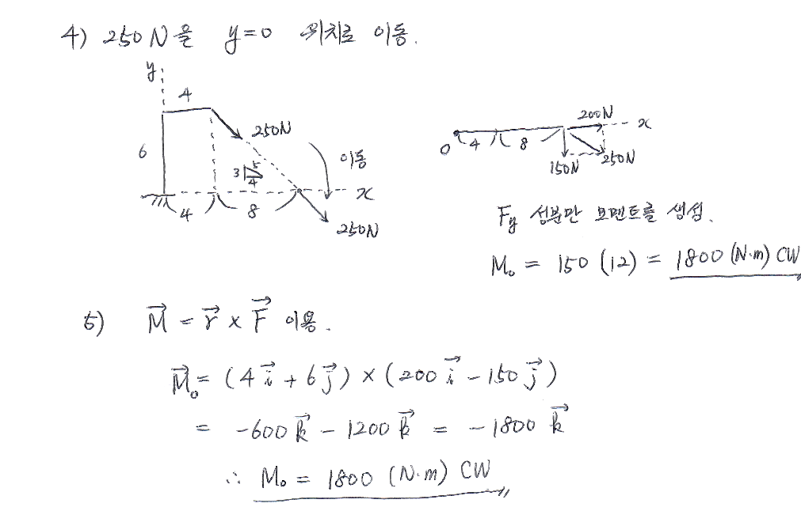

7. Pull the string tightly wound around the inner hub of the drum with a force T of 150N. (1) Find the moment of T with respect to the center C of the drum. (2) Find the angle θ that makes the moment about the contact point P zero. [Total 10 Points (5 Points each)]

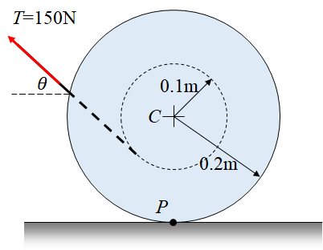

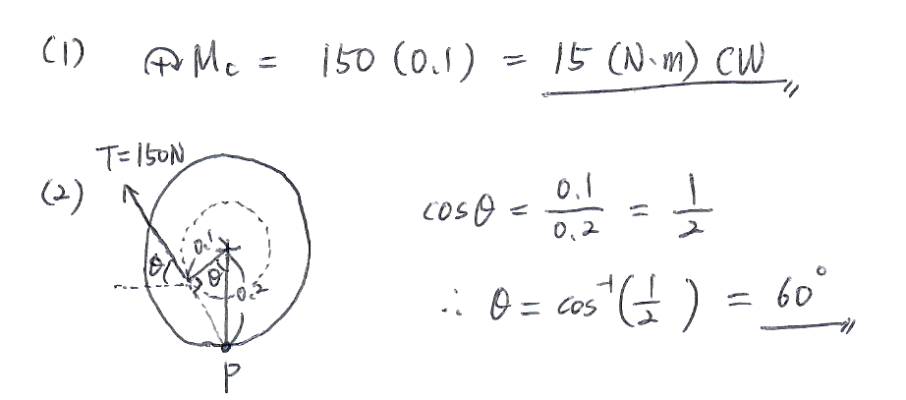

8. Replace the three forces acting on the bent pipe with one equivalent force R. Find the distance x between the point O and the point on the x-axis through which the line of action of the resultant force R passes. [Total 12 Points (Answer: 4 Points, Equations: 8 Points)]

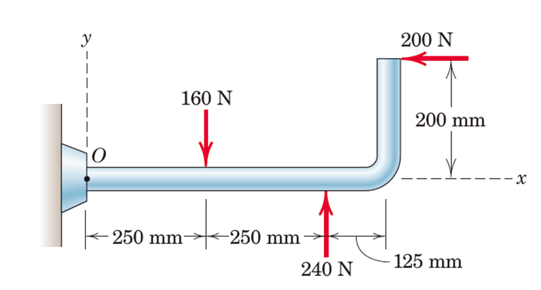

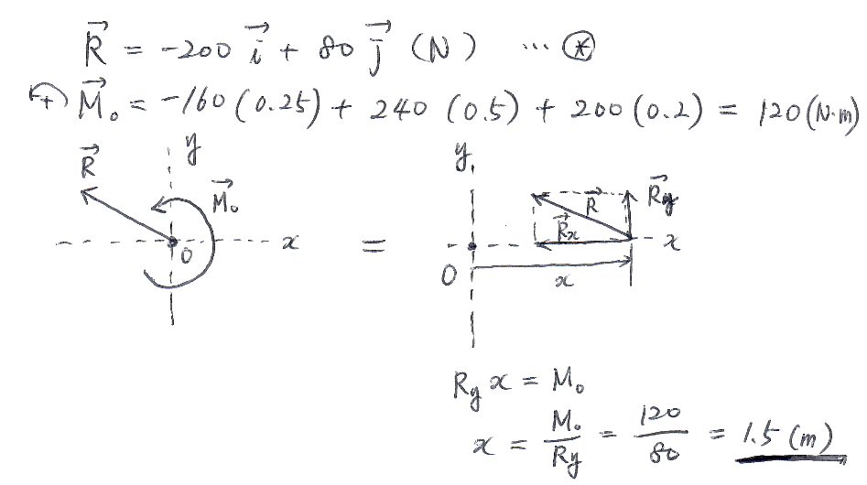9. A simple asymmetric simple truss is loaded as shown. Determine the reactions at A and D. Neglect the weight of the structure. [Total 12 Points (FBD: 4 Points, EoM: 6 Points, Answer: 2 Points)]

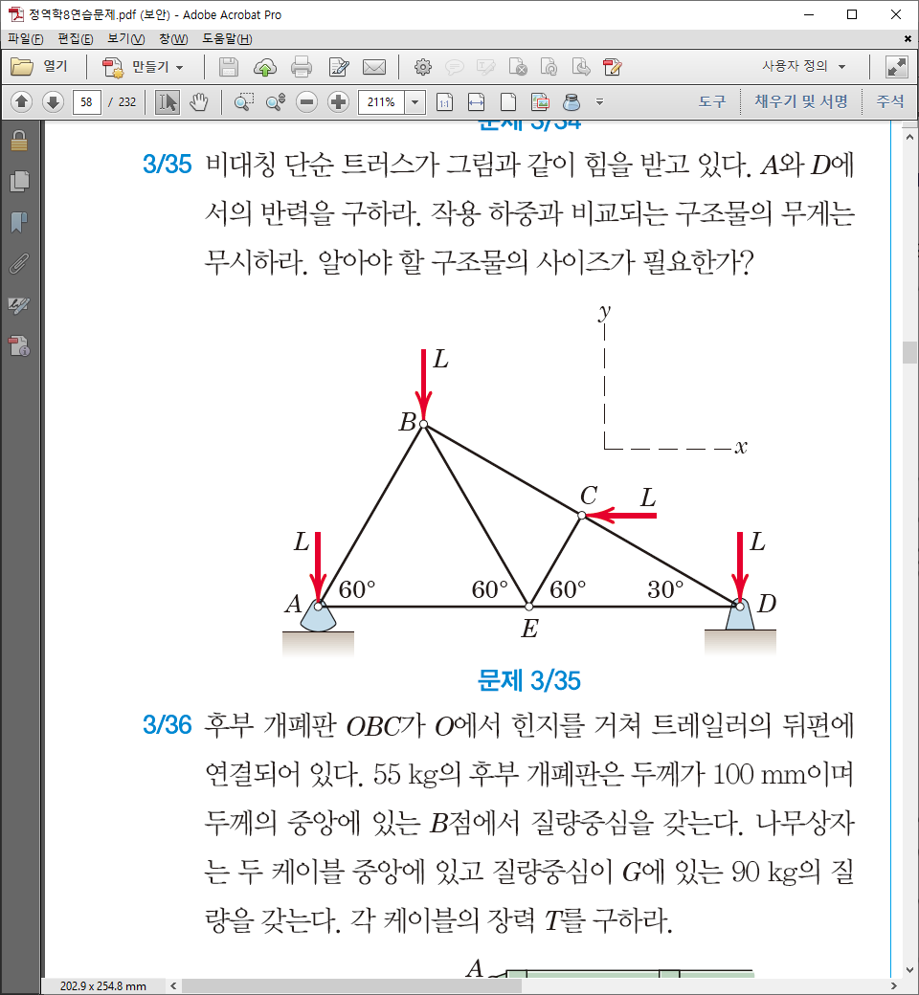

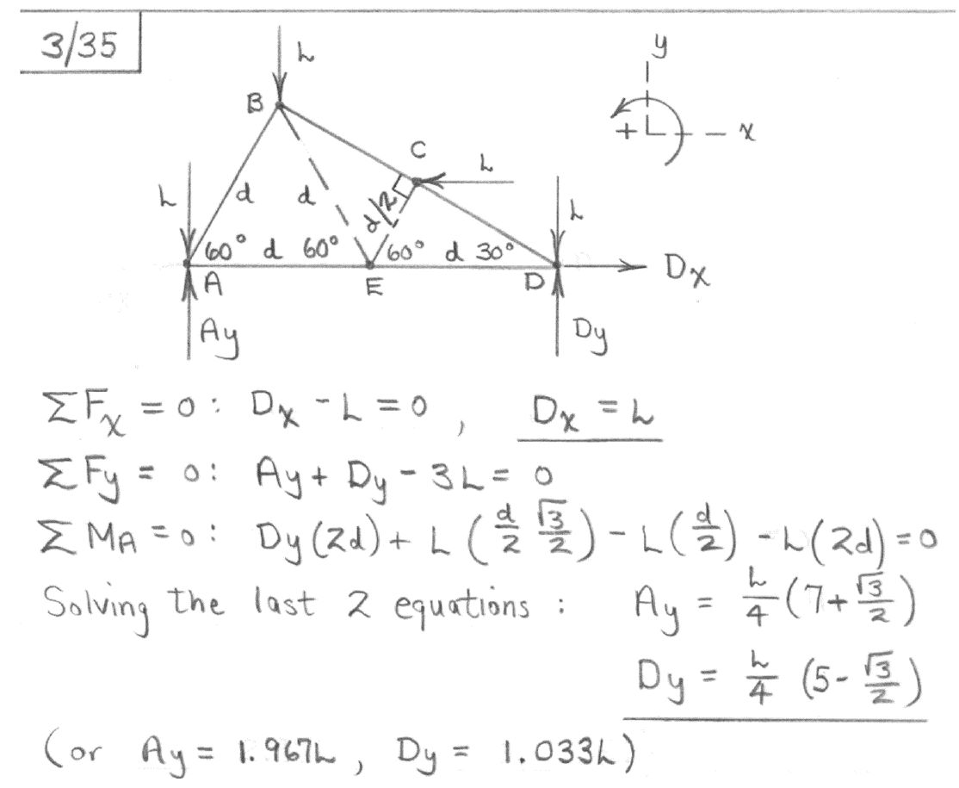

10. Calculate the tension T and the total force acting on the bearing of the pulley C in the cable supporting the pulley with a weight of 5000 N as shown in the figure. (Assume that the pulley can rotate freely for each bearing, and the weight of each part is smaller than the load of the load.) [Total 12 Points (Tension: 6 Points, Forces at C: 6 Points)]

